**Introduction to Database**

Akanksha Tyagi

Id-4701

JVM Trainee

Problem Statement: There can be multiple customers, who can place multiple orders on the site. Now a sales person can handle these orders will distribute into multiple sales persons (One order will be assign to one salesperson only). So a sales person can have multiple orders of multiple customers.

1. Create Database and 2. Design schema

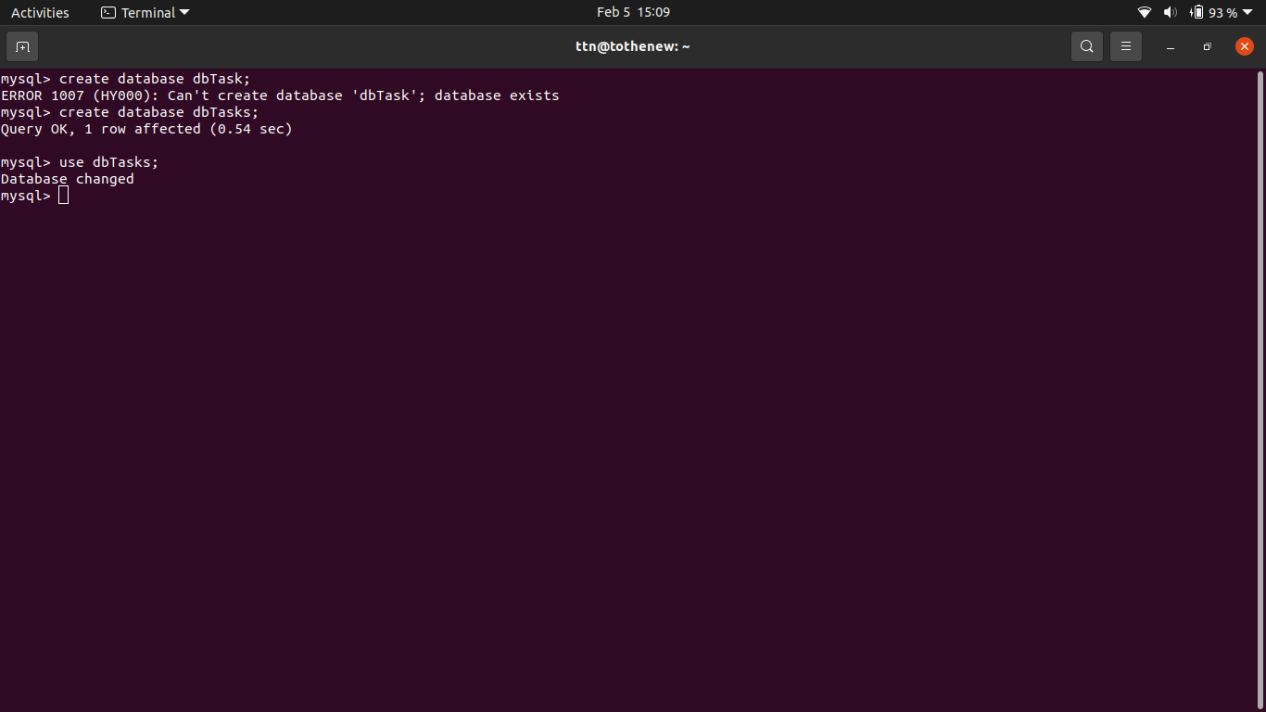

3. Create tables

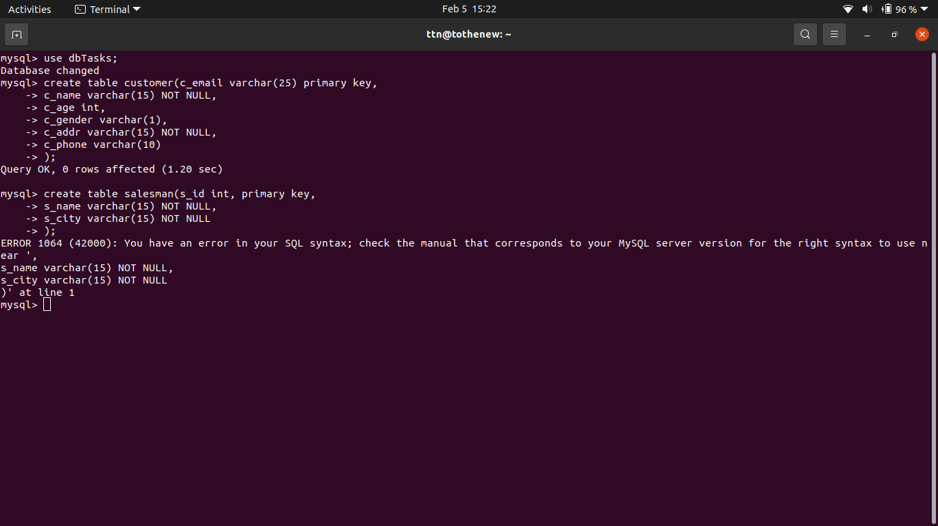

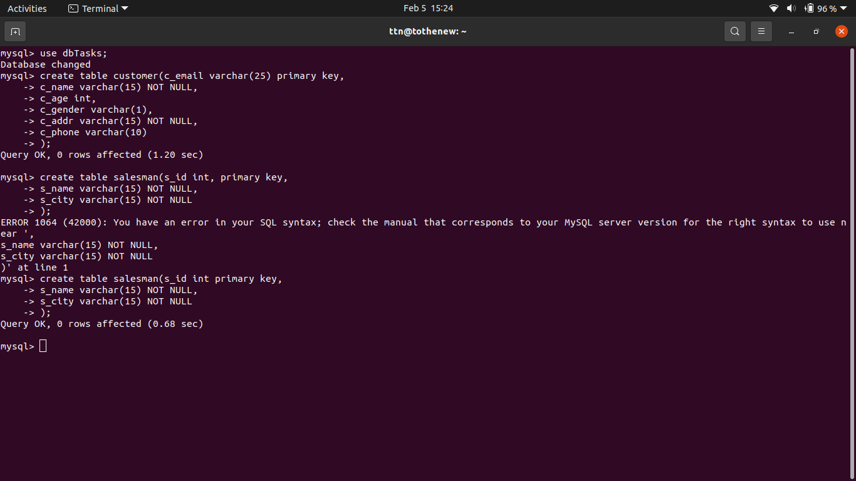

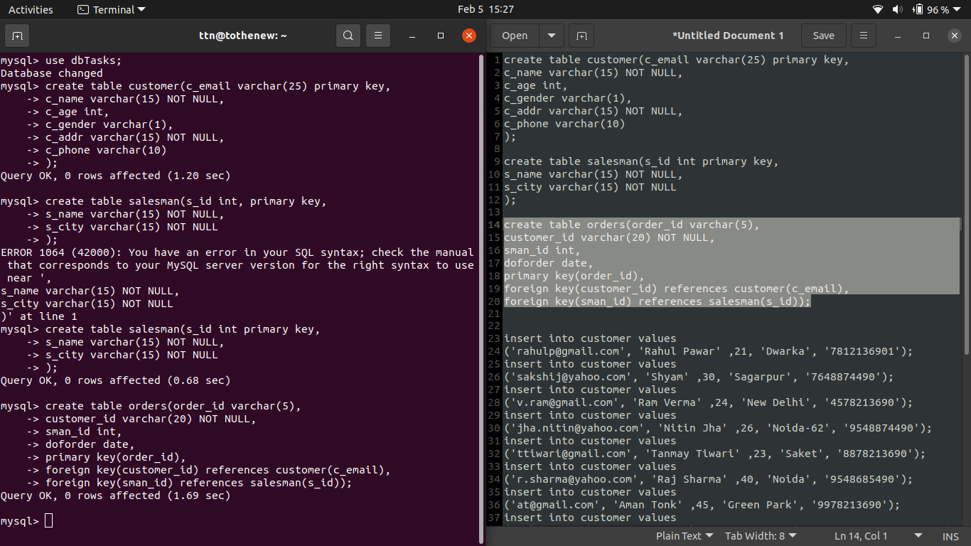

4. Insert sample data

‘Customer data’

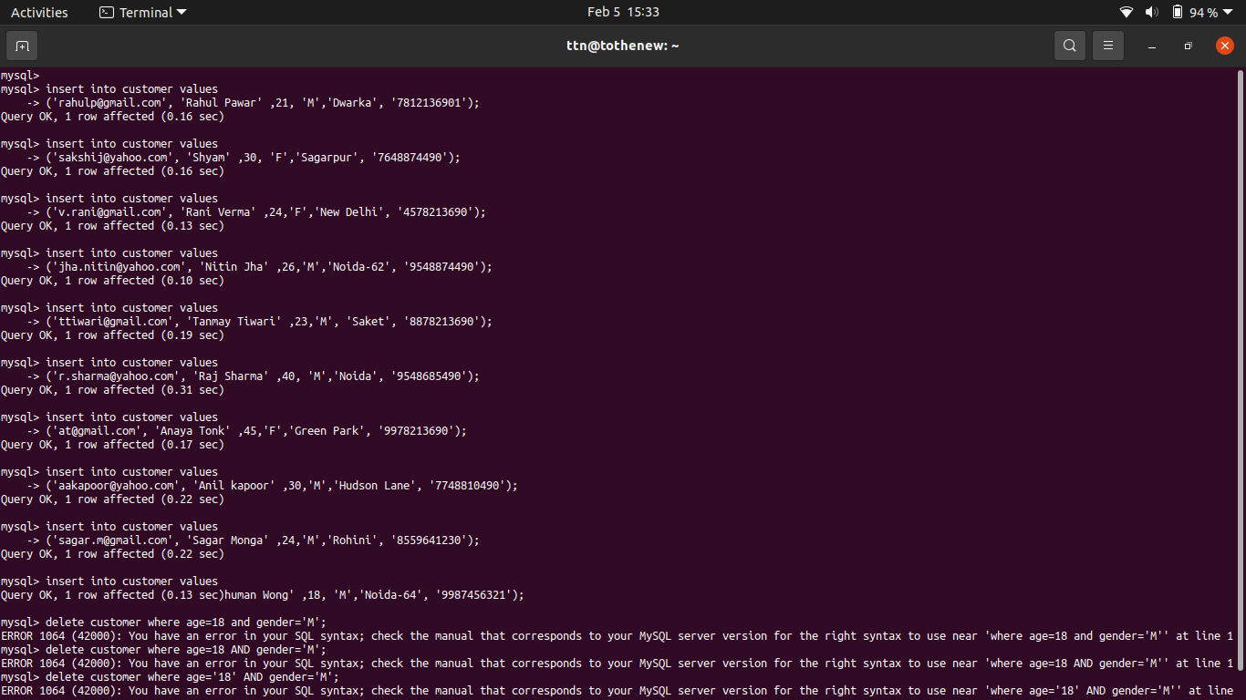

‘Salesman data’

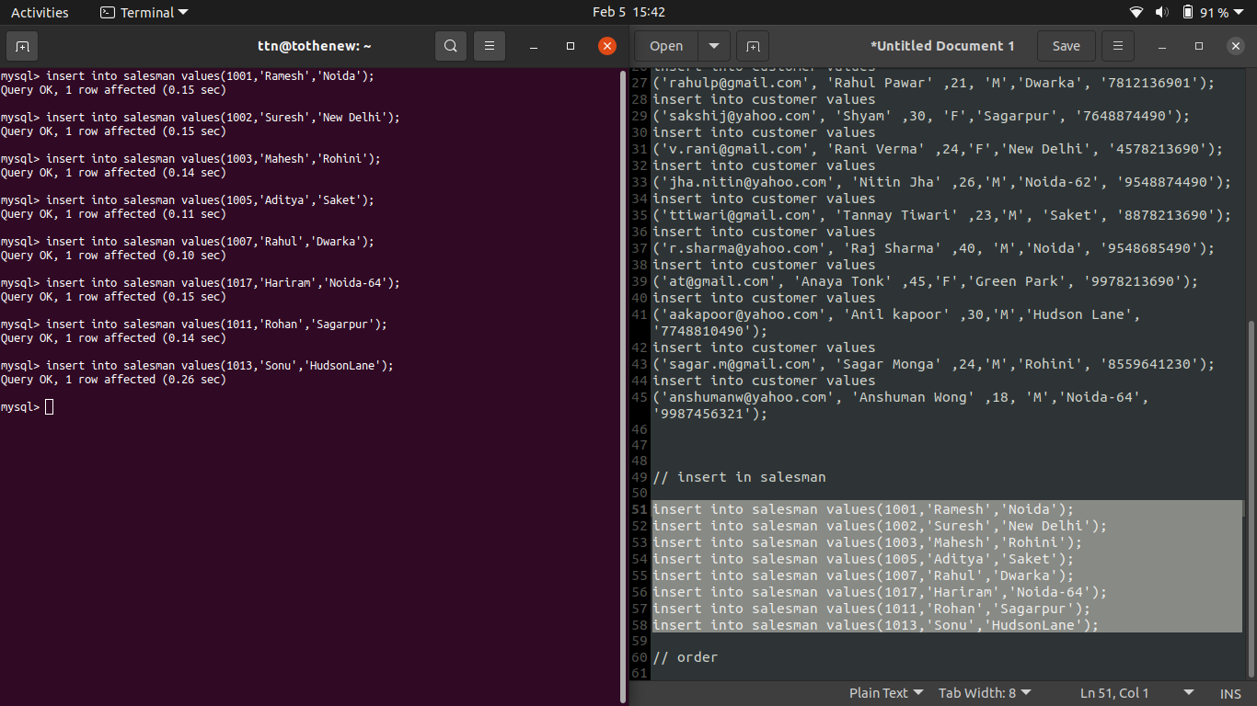

‘Order data’

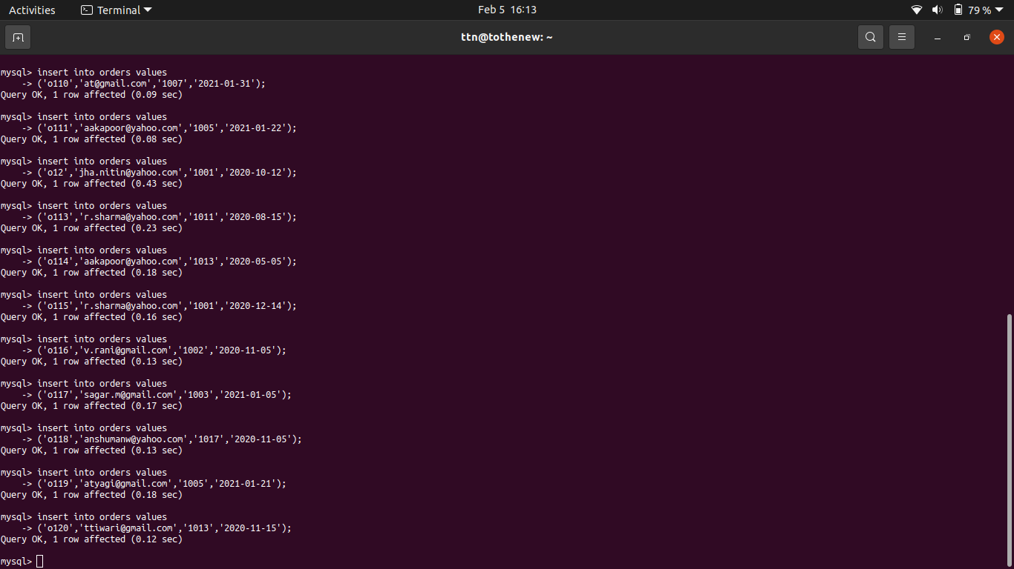

‘select queries’

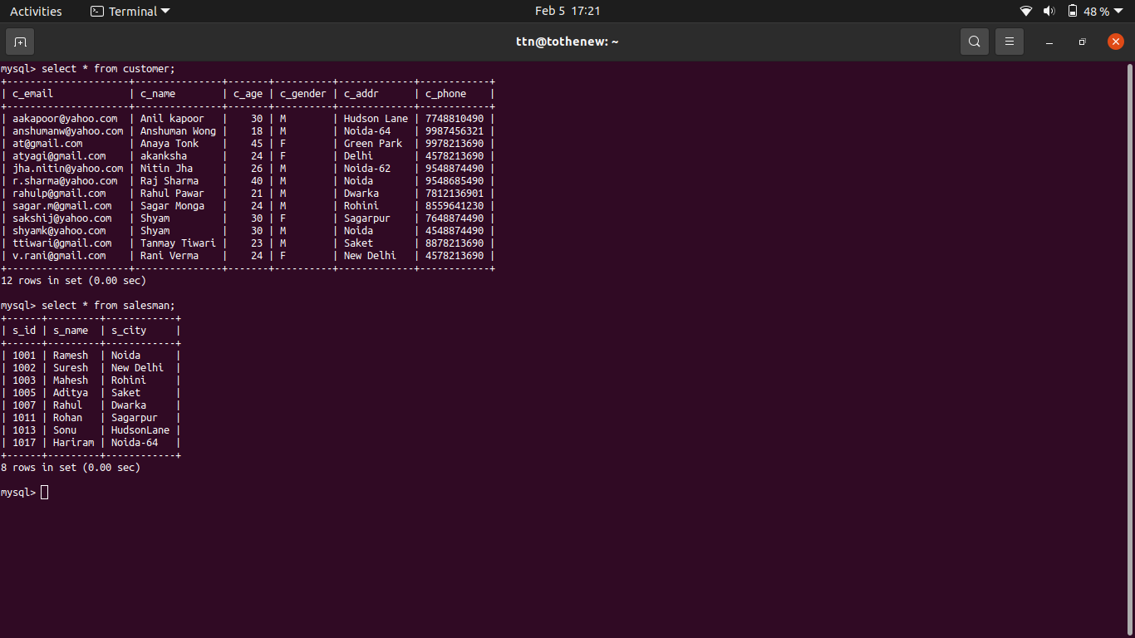

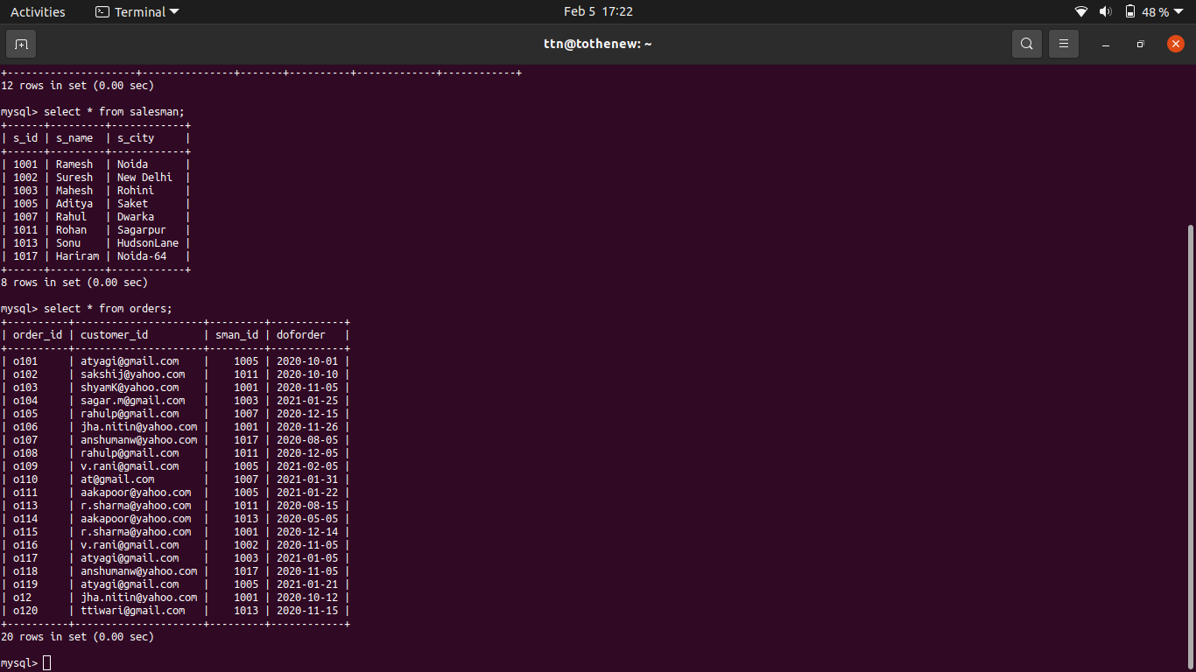

5. Find the sales person who has multiple orders.

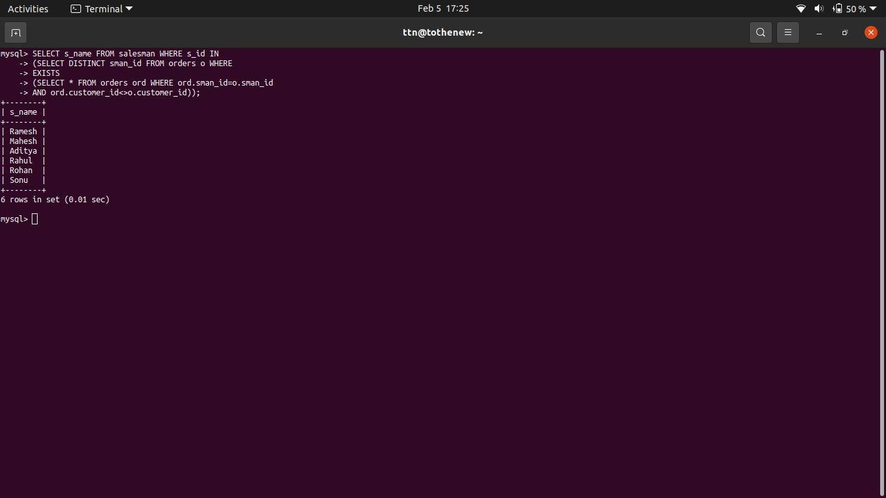

6. Find the all sales person details along with order details

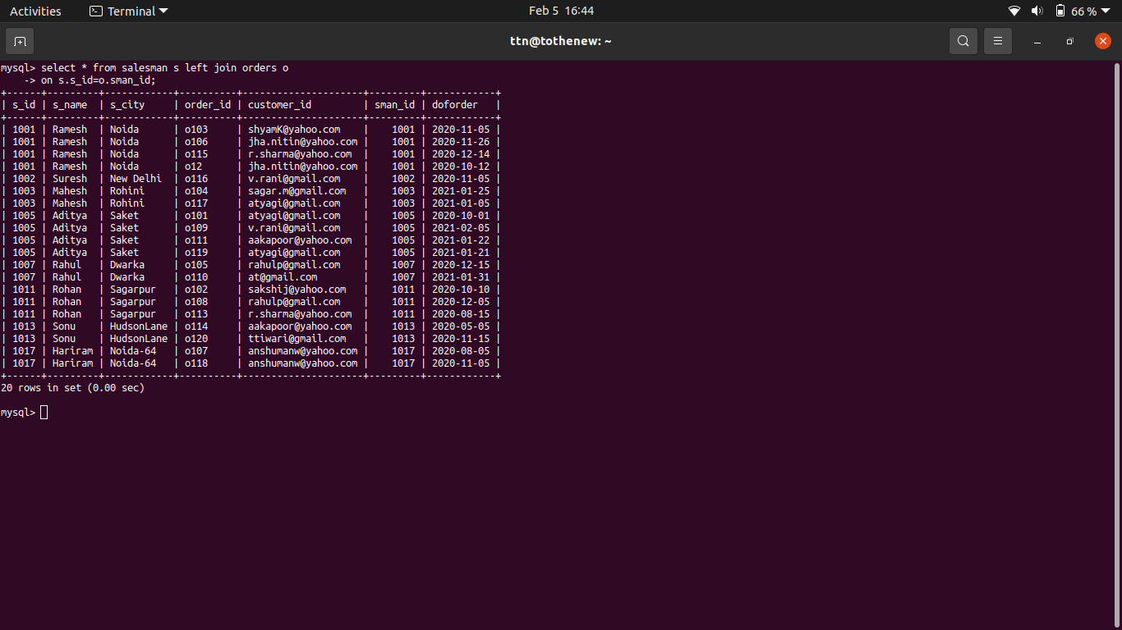

7. Create index

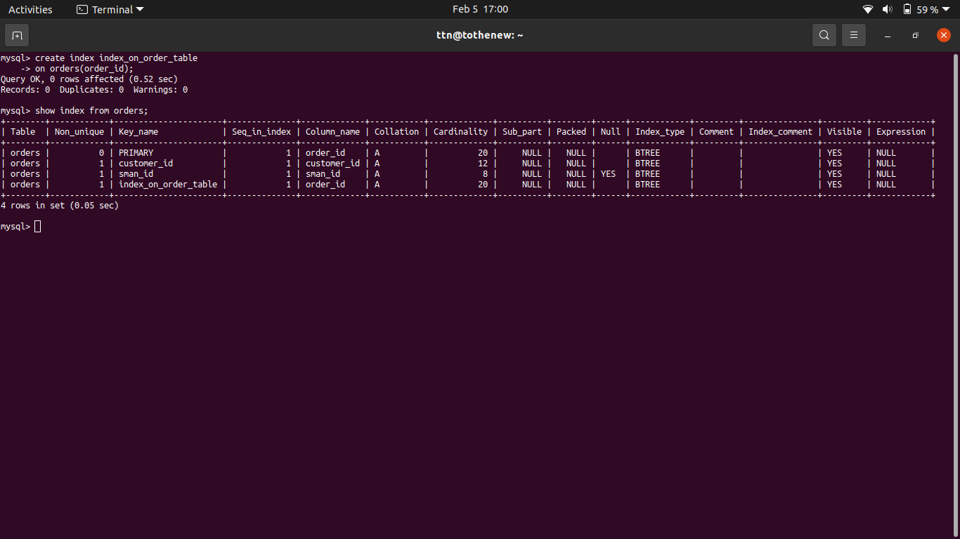

8. How to show index on a table





9. Find the order number, sale person name, along with the customer to whom that order belongs to

